Bahria University,
Karachi Campus


COURSE: CSC-221 DATA STRUCTURES AND ALGORITHM
TERM: FALL 2024, CLASS: BSE- 3 (C)

PROJECT NAME

Engr. Majid Kalim/ Engr. Saniya Sarim

N QUEEN PROBLEM + 8 QUEEN GAME

Signed Remarks: Score:

TABLE OF CONTENTS
INTRODUCTION 3
- PROBLEM STATEMENT 3
- PARADIGMS 4
  - Programming Style: 4
  - Graphical Interface 4
  - Code Structure 5
- ALGORITHM AND EXPLANATION 5
- ALGORITHM CODE 5
- INTERFACES 25
- CONCLUSION 29
- REFERENCES 29

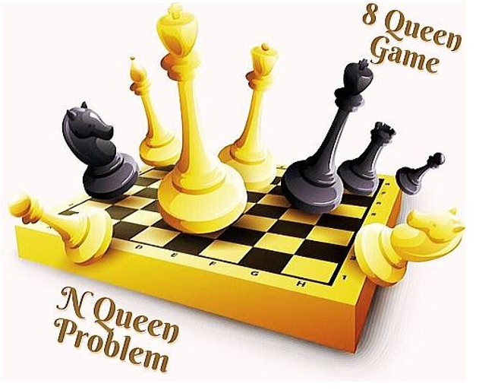

Group Members
Sr No. | Student Name | Reg No.
1 | Muhammad Abubakar (Group Lead) | 02-131232-052
2 | Fiza Khan | 02-131232-048
3 | Alishba Maqsood Alam | 02-131232-118
4 | Mustajab Haider | 02-131232-081

INTRODUCTION & PROBLEM:
INTRODUCTION:
1. The Queen Game is a classic puzzle where players place queens on a chessboard without them threatening each other.
2. Our project brings this game to life using C# and .NET Framework that allows for the creation of desktop applications with a user-friendly interface for an interactive experience.
3. The 8 Queen Game not only challenges players' strategic thinking but also enhances cognitive skills such as problem-solving and logical reasoning through interactive gameplay.
4. SQL 2022 is used to store data in database

Problem Statement:

1. Challenge: Strategically place queens without allowing them to share rows, columns, or diagonals.
2. Goal: Implement an engaging game with levels, allowing players to progress by smartly positioning queens.

Paradigms:

1. Programming Style: Object-Oriented Programming (OOP) is our go-to approach, modeling chess entities like queens and boards as objects.
2. Graphical interface: The graphical interface is crafted using c# .net, following the user-friendly event-driven paradigm.
3. Code Structure: We've organized the code into modular structures, promoting easy maintenance and reusability

ALGORITHM & EXPLANATION:
Core Algorithm:
1. The algorithm ensures queens are placed strategically, checking for threats.
2. Backtracking is employed to efficiently explore potential solutions.
3. Data Connection Management: The algorithm establishes a connection to the SQL database using SqlConnection, ensuring that the connection is open before executing queries.
4. Data Manipulation: It employs SQL commands to insert and retrieve data, using SqlCommand to execute queries that modify or access the database.
Features:
1. Level completion checks track progress.
2. Dynamic updates on the chessboard and a solution viewer enhance the gaming experience.
User Interaction:
1. Players progress intelligently through levels by making well-thought-out queen placements.
2. The graphical interface dynamically adjusts based on user moves and overall game progress.
Conclusion:
Our project seamlessly blends strategic problem-solving with an intuitive user interface, providing an enjoyable Queen Game experience

Algorithm Code:
Main Window Code
using System;
using System.Collections.Generic;
using System.Data;
using System.Data.SqlClient;
using System.Diagnostics;
using System.Linq;
using System.Text;
using System.Threading.Tasks;
using System.Windows;
using System.Windows.Controls;
using System.Windows.Data;
using System.Windows.Documents;
using System.Windows.Input;
using System.Windows.Media;
using System.Windows.Media.Imaging;
using System.Windows.Navigation;
using System.Windows.Shapes;

namespace MyAttemptAtQueens
{

public partial class MainWindow : Page
{
public SqlConnection sqlcon;
public Button[,] ChessBoard=new Button[8, 8] ;
private QueenSpot[,] ChessSpot=new QueenSpot [8,8];
public int [] QueenOnY = { 0, 0, 0, 0, 0, 0, 0, 0 };
public int TotalQueen = 0;
public Stopwatch watch = new Stopwatch();
public string name;

public MainWindow()
{
InitializeComponent();

int i = 0, j = 0; int u=1;
GridV.Children.Cast<Button>().ToList().ForEach(Chess =>
{

Chess.Content = " ";
ChessBoard[i, j] = Chess;

ChessSpot[i, j]= new QueenSpot(i, j, Chess);
j++;
if (j > 7)
{
i++;
j = 0;

});
watch.Start()
}

private void QueenPlacer(object sender, RoutedEventArgs e)
{

Button btn = sender as Button;
var column = Grid.GetColumn(btn);

var row = Grid.GetRow(btn);
if (!ChessSpot[row, column].HasQueen && ChessSpot[row, column].Accessible)
{
if (QueenOnY[row] == 0)
{
QueenOnY[row] = 1;
ChessSpot[row, column].HasQueen = true;
ChessSpot[row, column].Accessible = false;
TotalQueen++;
MarkUnAccessible(row, column);
var brush = new ImageBrush();
brush.ImageSource = new BitmapImage(new Uri("G:\\University\\Sem 5\\MyAttemptAtQueens\\MyAttemptAtQueens\\Chess Queen.png"));
btn.Background = brush;

btn.Content = " ";
CheckSpace(row, column);
textBlock1.Text = watch.ElapsedMilliseconds.ToString();

}
}
private void CheckSpace(int x,int y)
{
int flag = 0;
int check=0;
for (int i = 0; i < 8; i++)
{
for (int j = 0; j < 8; j++)
{
if (ChessSpot[i, j].Accessible == false || ChessSpot[i, j].HasQueen)
{
if (TotalQueen == 8)
{
flag = 0;
}
}
else {
flag = 1;
}
if(ChessSpot[i, j].Accessible == false)
{
check++;
}
}
}
if (flag == 0 && TotalQueen == 8)
{watch.Stop();
MessageBox.Show("YOU WON You place all 8 queens on 8*8 Grid");
}
else if (flag == 1)
{
textBlock3.Text = "Placed Queens" + TotalQueen;

}
if (check == 64 && TotalQueen < 8)
{ watch.Stop();
MessageBox.Show("You Lost");
}
}
public void MarkUnAccessible(int row, int col)
{
var brush = new ImageBrush();
brush.ImageSource = new BitmapImage(new Uri("G:\\University\\Sem 5\\MyAttemptAtQueens\\MyAttemptAtQueens\\Red X.png"));
try
{
for (int y = 0; y < 8; y++)
{
if (y == row) continue;
if(!ChessBoard[row, y].Content.Equals(" "))
ChessBoard[row, y].Background = brush;
ChessSpot[row, y].Accessible = false;
}
for (int x = 0; x < 8; x++)
{
if (col == x)
continue;

if (!ChessBoard[x, col].Content.Equals(" "))
ChessBoard[x, col].Background = brush;
ChessSpot[x, col].Accessible=false;
}
for (int j = 1; (row + j) <= 7 && (col + j) <= 7; j++)
{
ChessBoard[row + j, col + j].Background = brush;
ChessSpot[row + j, col + j].Accessible = false;
}
for (int j = 1; row - j >= 0 && col - j >= 0; j++)
{
ChessBoard[row - j, col - j].Background = brush;
ChessSpot[row - j, col - j].Accessible = false;
}
for (int j = 1; row + j <= 7 && col - j >= 0; j++)
{
ChessBoard[row + j, col - j].Background = brush;
ChessSpot[row + j, col - j].Accessible = false;
}
for (int j = 1; row - j >= 0 && col + j <= 7; j++)
{
ChessBoard[row - j, col + j].Background = brush; ;
ChessSpot[row - j, col + j].Accessible = false;
}
}
catch (Exception ex) { }
}
private void playAgain_Click(object sender, RoutedEventArgs e)
{
this.avigationService.Refresh();

}
private void Exit_Click(object sender, RoutedEventArgs e)
{
try
{
SqlConnection sqlcon;
string connectionstring;

connectionstring = "Data Source = DESKTOP-I5DML83\\SQLEXPRESS; Integrated Security = True";
sqlcon = new SqlConnection(connectionstring);
if (sqlcon.State != ConnectionState.Open)
{
sqlcon.Open();
}
string query = "INSERT INTO UserScore (Name,Score) VALUES('Player' , " + textBlock1.Text + ")";
using (SqlCommand sqlcmd = new SqlCommand(query, sqlcon))
{
sqlcmd.ExecuteNonQuery();
}
this.NavigationService.Navigate(new Uri("ExitPage.xaml", UriKind.RelativeOrAbsolute));
}
catch (Exception ex) {
this.NavigationService.Navigate(new Uri("ExitPage.xaml", UriKind.RelativeOrAbsolute));
}
}
}
}
INTERFACES
